Reception Weekly Challenge wk beg. 11th May
How Many Legs?
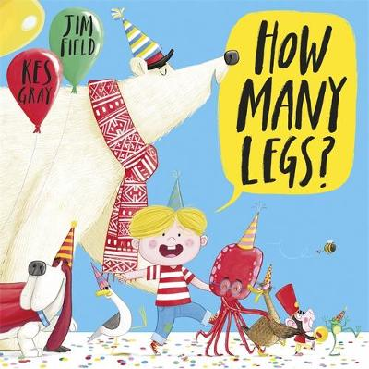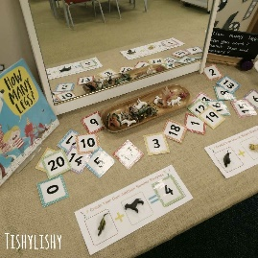
https://www.youtube.com/watch?v=gmUY5bXkVKQ (story)
- Explore the number of legs different animals have.
- Count the legs accurately and match numbers to pictures / toys.
- Try making number sentences for different creatures
e.g. using toys, drawings or pictures from the internet / books.
- You could use the symbols + (for adding animals),
- (for taking away or finding the difference between animals)
and = (to find how many altogether, how many left,
how many more or less).
- You might even make a really long number sentence with
more than 2 animals eg. 2+4+8+0=?
- For an extra challenge get your grown ups to make up some
problems for you to solve. You could also make some up for them!
Eg -How many legs were there in the whole story?
-Can you keep count as you read? OOOH TRICKY!!!!!
-Have a go at counting in twos – how many legs would 5 ducks have? Etc.
-Doubles- how many legs would 2 dogs or 2 ladybirds have? Etc.
-How many legs would a duck, a dog and an octopus have? Etc
-If there were 3 cats walking along the wall how many legs
would you see? Etc
You could find a creative way to illustrate your number sentences
by taking a photo of toys, drawing, printing, stamping, using
stickers or anything else you have at home.

We are looking forward to seeing your ideas.
Email to red@nauntonpark.gloucs.sch.uk or green@nauntonpark.gloucs.sch.uk

