

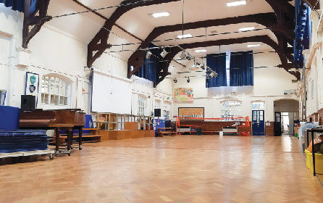
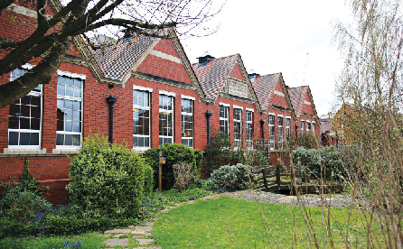




Naunton Park Primary School

VENUE HIRE

Our unique premises is available to hire for clubs, societies and other organisations for regular and varied events.
Term time:

After school hours and all day at weekends
School holidays: Access all day every day
Excellent
rates!

Large internal and external spaces available which can be separated to smaller sections if required.
Long-term
discounts
Main Hall approximately 21m x 8m
lower Hall approximately 10m x 7m Various smaller internal spaces and workrooms
Floodlit outdoor areas

Included
- Full Health & Safety compliance including Public
and Employers Liability insurance
- Kitchenette and toilet facilities
- Full support and induction of premises and security
Applications for short and long term bookings considered.
For further information and to book please contact Helen Nash

ﬁnance@nauntonpark.gloucs.sch.uk
01242 513114
Support your local community

