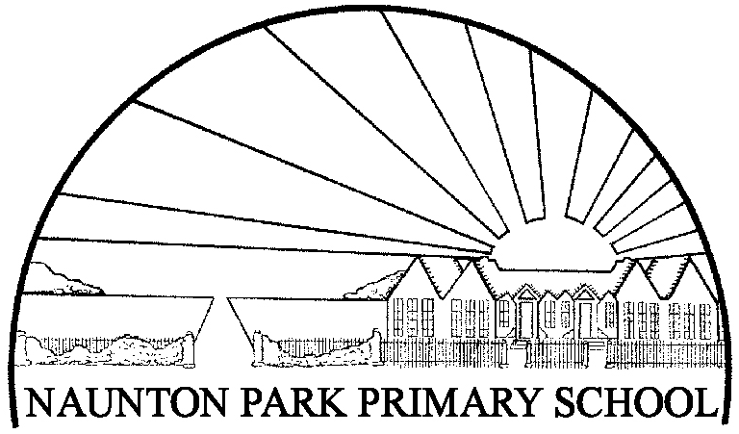Naunton Park Primary School
Physical Education Policy

Last review date: March 2023
Next review date: September 202

1.0 Introduction and aims

Our PE curriculum aims to support pupils to develop a love of sport and physical exercise. Our inclusive and challenging curriculum provides a variety of sporting activities to engage, encourage
and support all children in developing a mastery of the skills and qualities required so that they are well- prepared for secondary school and go on to lead heathy, productive and active lives.

The PE Session at Naunton Park Primary School demand that children work hard. Lessons focus on ensuring sustained activity through dynamic warm ups, carefully scaffolded practise and conditioned games, which enable children to develop and apply their skills in increasingly challenging and competitive situations. The skills that staff encourage, such as such as teamwork and leadership, apply not only to PE, but their wider lives, preparing them for a variety of social situations. By encouraging students to strive to beat their personal bests, participate in a conditioned game or representing their house or school in organised competition, children will earn a sense of pride and take ownership of their own physical development, inspiring a love for physical activity.

By consistently interweaving competition into lessons, in its many forms, children experience fun opportunities to challenge themselves, experience a sense of achievement and develop important sporting values and personal qualities such as humility, resilience, determination and empathy. The Real PE scheme used at Naunton Park helps all staff to deliver meaningful and engaging lessons.

Naunton Park aims to provide opportunities to work with various outside providers, participate in sports leagues around the county and attend competition to help inspire children to develop their skills to the highest level, giving them opportunities to develop into the elite athletes of the future.

Aims and Objectives
The Aim of Physcial Education at Naunton Park Primary School is to:

To develop skilful use of the body, the ability to remember, repeat and refine actions, and to perform them with increasing control, co-ordination and fluency.(Acquiring and developing.)

To develop increasing ability to select, link and apply skills, tactics and compositional ideas. (Selecting and applying.)

To improve observational skills and the ability to describe and make simple judgements of their own and others’ work, and to use their observations and judgements to improve performance. (Improving and evaluating.)

To develop an understanding of the effects of exercise on the body, and an appreciation of the value of safe exercising. (Knowledge and understanding of fitness and health.)

To develop the ability to work independently, and communicate with and respond positively towards others. (Working alone and with others.)

To promote an understanding of safe practice, and develop a sense of responsibility towards their own and others’ safety and well-being.

Curriculum

Children will be expected to participate in the full range of activities in the physical
education curriculum.

At KS1 pupils are taught knowledge, skills and understanding through the following
areas of activity:
- Games
- Athletics
- Gymnastics
- Dance.

At KS2 pupils are taught knowledge, skills and understanding through the following
areas of activity:
- Gymnastics
- Dance
- Games
- Athletics
- Problem Solving/Outdoor and Adventurous activities (Multi Skills or Real PE)
- Swimming and water safety

Equal opportunities and Inclusion

Activities are made available to all through adaptive teaching during the teacher planning phase. It is in our SEND policy that we will ensure that every child receives an equal opportunity within PE activities, regardless of race, gender, ability, or Special Education Needs.

Special Educational Needs SENDS

Any children who are identified as having ‘special educational needs’ are given the help that they require. Where children have a degree of physical or behavioural difficulties, they should be encouraged to participate in PE activities with help from others. Children with Special Educational Needs will take as full a part in the Physical Education programme as they are able. Depending on their level of disability or need, they will be able to experience most activities although some adaptations to the curriculum may need to be made. For further advice and guidance, class teachers should consult with the SENCO and/or the Physical Education Coordinator.

Resources

Naunton Park Primary School has a school hall, which is equipped with portable and fixed apparatus for gymnastics suitable for both KS1 and KS2. Located at the back of the school is a long playground equipped with line marking for a variety of sports such as netball, basketball futsal football. Markings located on other areas of the playground can be used for various multi-skill games or EYFS activities designed to help learn through play. The School playground is also equipped with apparatus to support physical activity and play. The school is next to Naunton Park which is also used for physical activities. Resources for PE are kept in two stores; the indoor Pe cupboard and the outdoor PE container.

The PE Subject Leader makes an annual audit of equipment and resources, providing an up-dated list to staff. All lost or damaged resources need to be reported to the PE Subject Leader.

Assessment

Extra-curricular activity

The purpose of extra-curricular activities at Naunton Park is to:
- Extend children’s learning
- Raise standards in PE
- Provide for all abilities
- Encourage fitness for life and increase daily physical activity
- Provide opportunities for inter / intra school competition (festivals, leagues etc.)

After school and lunch time sports/physical activity clubs are made available for as many children as possible, though for safety reasons there will be a necessary limit on numbers in individual clubs. The number of clubs we can offer may be impacted by funding. All children participating in after school clubs will have returned signed permission slips. Registers are taken at clubs to ensure the children are attending regularly. Registers are kept to identify those who do not take part in (extra) regular exercise. Those who are identified can then be invited to some clubs exclusively for children who do not engage with a large amount of physical activity without the worry of being overshadowed by more confident children.

Health and Safety

Class teachers and adults other than teachers are responsible for the safety of the children in their care. Safety rules that all at Naunton Park need to adhere to are:
- PE kit and jewellery rules are understood by the children and are enforced
- The teaching area and equipment are assessed for safety prior to a lesson
- Children are taught how to safely get out, carry, use and put away equipment - no pupils are allowed in the equipment store unsupervised
- Any problems with unsafe or damaged equipment are reported to the PE Subject leader or Head Teacher
- Accidents should be logged in the accident book and parents should be informed when necessary
- Staff are aware of the fire procedures when leaving the hall
- Staff and children should be aware of emergency procedures at the swimming baths

Cross-Curricular Opportunities

Whilst retaining its unique contribution to a pupil’s movement education, PE also has considerable potential to contribute to much wider areas of learning. As well as dance themes reflecting topics, links can be made to other areas of the curriculum such as:
- ICT (Information, Communication Technology)– performances recorded using photography and video for use in self-evaluation and demonstration of good practice, or for visual stimuli
- PSHE (Personal, Social and Health Education) – leading, managing, co-operating and decision-making skills
- SCIENCE – planning, predicting and testing ideas; health and fitness – learning about the body
- LITERACY – asking relevant questions; communicating ideas; listening skills
- NUMERACY – counting, measuring, calculating – distance, time, repetitions.

Sports Premium Funding

The government has provided additional funding to improve the provision of physical education (PE), sport and activity in primary schools was allocated to primary school Headteachers. This funding is ring-fenced and therefore can only be spent on provision of PE, sport and activity in schools. See our website for full details of how our school has spent the Sports Premium.

Safeguarding

Use of any external personnel including sports coaches and volunteers will be in line with the schools policy on Safeguarding and DBS / staffing checks. Please also refer to the school’s health and safety policy and risk assessment file.

Review

This Policy was review in March 2023 and will be reviewed again in line with school development policy in September 2023.

