 | Early Years Outcomes  The main Early Years Outcomes covered in the Athletics units are:  - Shows increasing control over an object in pushing, patting, throwing, catching or kicking it.  - Children show good control and co-ordination in large and small movements.  - Negotiates space successfully when playing racing and chasing games with other children, adjusting speed or changing direction to avoid obstacles.  - Experiments with different ways of moving.  - They move confidently in a range of ways, safely negotiating space. |  |  |  | KS1 National Curriculum Aims  Pupils should develop fundamental movement skills, become increasingly competent and confident and access a broad range of opportunities to extend their agility, balance and coordination, individually and with others. They should be able to engage in competitive (both against self and against others) and co-operative physical activities, in a range of increasingly challenging situations. Pupils should be taught to:  - master basic movements including running, jumping, throwing and catching, as well as developing balance, agility and co-ordination, and begin to apply these in a range of activities;  - participate in team games, developing simple tactics for attacking and defending. |  |  |  | KS2 National Curriculum Aims  Pupils should continue to apply and develop a broader range of skills, learning how to use them in different ways and to link them to make actions and sequences of movement. They should enjoy communicating, collaborating and competing with each other. They should develop an understanding of how to improve in different physical activities and sports and learn how to evaluate and recognise their own success. Pupils should be taught to:  - use running, jumping, throwing and catching in isolation and in combination;  - play competitive games, modified where appropriate [for example, badminton, basketball, cricket, football, hockey, netball, rounders and tennis], and apply basic principles suitable for attacking and defending;  - develop flexibility, strength, technique, control and balance [for example, through athletics and gymnastics];  - compare their performances with previous ones and demonstrate improvement to achieve their personal best.
 |  | Reception 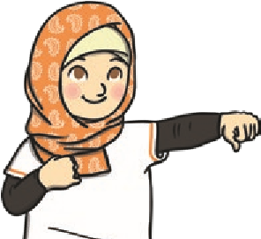 | Year 1 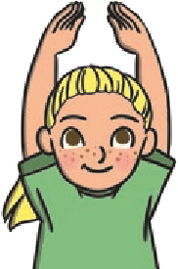 |  |  | Year 2 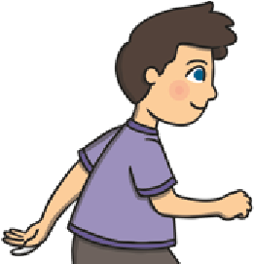 | Year 3 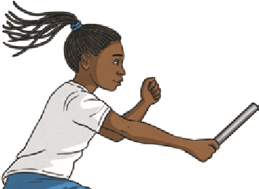 |  |  | Year 4 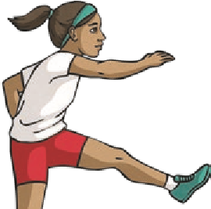 | Year 5 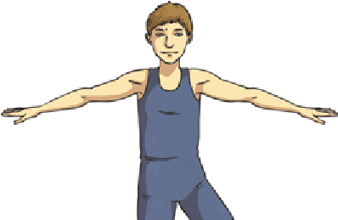 | Year 6 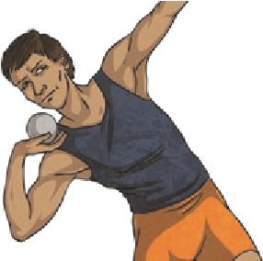
 |  |  |  |  |  |  | Health and Fitness
 |  | Describe how the body feels when still and when exercising. | Describe how the body feels before, during and after exercise.  Carry and place equipment safely. |  |  | Recognise and describe how the body feels during and after different physical activities.  Explain what they need to stay healthy. | Recognise and describe the effects of exercise on the body.  Know the importance of strength and flexibility for physical activity.  Explain why it is important to warm up and cool down. |  |  | Describe how the body reacts at different times and how this affects performance.  Explain why exercise is good for your health.  Know some reasons for warming up and cooling down. | Know and understand the reasons for warming up and cooling down.  Explain some safety principles when preparing for and during exercise. | Understand the importance of warming up and cooling down.  Carry out warm-ups and cool-downs safely and effectively.  Understand why exercise is good for health, fitness and wellbeing.  Know ways they can become healthier.
 |  |  |  |  |  |  | Running
 |  | Run in different ways for a variety of purposes. | Vary their pace and speed when running.  Run with a basic technique over different distances.  Show good posture and balance.  Jog in a straight line.  Change direction when jogging.  Sprint in a straight line.  Change direction when sprinting.  Maintain control as they change direction when jogging or sprinting. |  |  | Run at different paces, describing the different paces.  Use a variety of different stride lengths.  Travel at different speeds.  Begin to select the most suitable pace and speed for distance. Complete an obstacle course.  Vary the speed and direction in which they are travelling.  Run with basic techniques following a curved line.  Be able to maintain and control a run over different distances. | Identify and demonstrate how different techniques can affect their performance.  Focus on their arm and leg action to improve their sprinting technique.  Begin to combine running with jumping over hurdles.  Focus on trail leg and lead leg action when running over hurdles.  Understand the importance of adjusting running pace to suit the distance being run. |  |  | Confidently demonstrate an improved technique for sprinting.  Carry out an effective sprint finish.  Perform a relay, focusing on the baton changeover technique.  Speed up and slow down smoothly. | Accelerate from a variety of starting positions and select their preferred position.  Identify their reaction times when performing a sprint start.  Continue to practise and refine their technique for sprinting, focusing on an effective sprint start.  Select the most suitable pace for the distance and their fitness level in order to maintain a sustained run.  Identify and demonstrate stamina, explaining its importance for runners. | Recap, practise and refine an effective sprinting technique, including reaction time.  Build up speed quickly for a sprint finish.  Run over hurdles with fluency, focusing on the lead leg technique and a consistent stride pattern.  Accelerate to pass other competitors.  Work as a team to competitively perform a relay.  Confidently and independently select the most appropriate pace for different distances and different parts of the run.  Demonstrate endurance and stamina over longer distances in order to maintain a sustained run.

 | Reception | Year 1 | Year 2 | Year 3 | Year 4 | Year 5 | Year 6
 |  |  |  | Jumping
 | Jump in a range of ways, landing safely. | Perform different types of jumps: for example, two feet to two feet, two feet to one foot, one foot to same foot or one foot to opposite foot.  Perform a short jumping sequence.  Jump as high as possible.  Jump as far as possible.  Land safely and with control. Work with a partner to develop the control of their jumps. | Perform and compare different types of jumps: for example, two feet to two feet, two feet to one foot, one foot to same foot or one foot to opposite foot.  Combine different jumps together with some fluency and control.  Jump for distance from a standing position with accuracy and control.  Investigate the best jumps to cover different distances.  Choose the most appropriate jumps to cover different distances.  Know that the leg muscles are used when performing a jumping action. | Use one and two feet to take off and to land with.  Develop an effective take-off for the standing long jump.  Develop an effective flight phase for the standing long jump.  Land safely and with control. | Learn how to combine a hop, step and jump to perform the standing triple jump.  Land safely and with control.  Begin to measure the distance jumped. | Improve techniques for jumping for distance.  Perform an effective standing long jump.  Perform the standing triple jump with increased confidence.  Develop an effective technique for the standing vertical jump (jumping for height) including take-off and flight.  Land safely and with control.  Measure the distance and height jumped with accuracy. Investigate different jumping techniques. | Develop the technique for the standing vertical jump.  Maintain control at each of the different stages of the triple jump.  Land safely and with control.  Develop and improve their techniques for jumping for height and distance and support others in improving their performance.  Perform and apply different types of jumps in other contexts.  Set up and lead jumping activities including measuring the jumps with confidence and accuracy.
 |  |  |  | Throwing
 | Roll equipment in different ways.  Throw underarm.  Throw an object at a target. | Throw underarm and overarm. Throw a ball towards a target with increasing accuracy.  Improve the distance they can throw by using more power. | Throw different types of equipment in different ways, for accuracy and distance.  Throw with accuracy at targets of different heights.  Investigate ways to alter their throwing technique to achieve greater distance. | Throw with greater control and accuracy.  Show increasing control in their overarm throw.  Perform a push throw.  Continue to develop techniques to throw for increased distance. | Perform a pull throw.  Measure the distance of their throws. Continue to develop techniques to throw for increased distance. | Perform a fling throw.  Throw a variety of implements using a range of throwing techniques.  Measure and record the distance of their throws.  Continue to develop techniques to throw for increased distance. | Perform a heave throw.  Measure and record the distance of their throws.  Continue to develop techniques to throw for increased distance and support others in improving their personal best.  Develop and refine techniques to throw for accuracy.
 |  |  |  | Compete/Perform
 | Control their body when performing a sequence of movements Participate in simple games | Begin to perform learnt skills with some control.  Engage in competitive activities and team games. | Perform learnt skills with increasing control.  Compete against self and others. | Perform learnt skills and techniques with control and confidence.  Compete against self and others in a controlled manner. | Perform and apply skills and techniques with control and accuracy.  Take part in a range of competitive games and activities. | Consistently perform and apply skills and techniques with accuracy and control.  Take part in competitive games with a strong understanding of tactics and composition. | Perform and apply a variety of skills and techniques confidently, consistently and with precision.  Take part in competitive games with a strong understanding of tactics and composition.
 |  |  |  | Evaluate
 | Talk about what they have done.  Talk about what others have done. | Watch and describe performances.  Begin to say how they could improve. | Watch and describe performances, and use what they see to improve their own performance.  Talk about the differences between their work and that of others. | Watch, describe and evaluate the effectiveness of a performance.  Describe how their performance has improved over time. | Watch, describe and evaluate the effectiveness of performances, giving ideas for improvements.  Modify their use of skills or techniques to achieve a better result. | Choose and use criteria to evaluate own and others’ performance.  Explain why they have used particular skills or techniques, and the effect they have had on their performance. | Thoroughly evaluate their own and others’ work, suggesting thoughtful and appropriate improvements.

