 | Early Years Outcomes  The main Early Years Outcomes covered in the Dance units are:  - Moves freely and with pleasure and confidence in a range of ways, such as slithering, shuffling, rolling, crawling, walking, running, jumping, skipping, sliding and hopping.  - Experiments with different ways of moving.  - Children show good control and coordination in large and small movements. They move confidently in a range of ways, safely negotiating space.  - Enjoys joining in with dancing and ring games.  - Beginning to move rhythmically.  - Imitates movement in response to music.  - Begins to build a repertoire of songs and dances.  - Children sing songs, make music and dance, and experiment with ways of changing them.  - Developing preferences for forms of expression.  - Uses movement to express feelings.  - Creates movement in response to music.  - Captures experiences and responses with a range of media, such as dance.  - Initiates new combinations of movement and gesture in order to express and respond to feelings, ideas and experiences.  - • Children represent their own ideas, thoughts and feelings through dance. |  |  |  |  |  | KS1 National Curriculum Aims  Pupils should develop fundamental movement skills, become increasingly competent and confident and access a broad range of opportunities to extend their agility, balance and coordination, individually and with others. They should be able to engage in competitive (both against self and against others) and co-operative physical activities, in a range of increasingly challenging situations.  Pupils should be taught to:  - master basic movements including running, jumping, throwing and catching, as well as developing balance, agility and coordination, and begin to apply these in a range of activities;  - perform dances using simple movement patterns. |  |  |  | KS2 National Curriculum Aims  Pupils should continue to apply and develop a broader range of skills, learning how to use them in different ways and to link them to make actions and sequences of movement. They should enjoy communicating, collaborating and competing with each other. They should develop an understanding of how to improve in different physical activities and sports and learn how to evaluate and recognise their own success.  Pupils should be taught to:  - develop flexibility, strength, technique, control and balance [for example, through athletics and gymnastics];  - perform dances using a range of movement patterns;  - compare their performances with previous ones and demonstrate improvement to achieve their personal best.
 |  | Reception 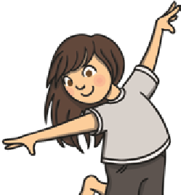 | Year 1 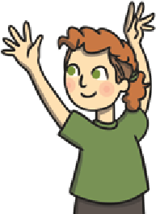 | Year 2 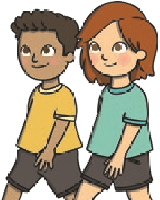 | Year 3 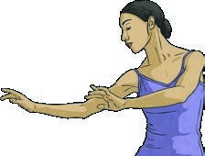 |  |  | Year 4 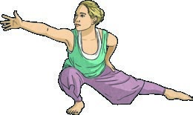 | Year 5 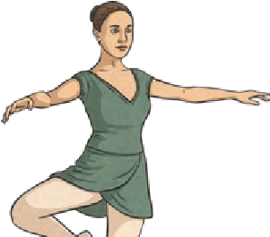 |  |  | Year 6 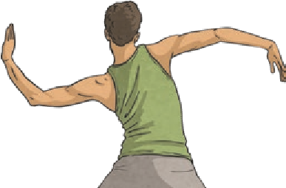
 |  |  |  |  | Health and Fitness
 |  | Describe how the body feels when still and when exercising. | Describe how the body feels before, during and after exercise.  Carry and place equipment safely. | Recognise and describe how the body feels during and after different physical activities.  Explain what they need to stay healthy. | Recognise and describe the effects of exercise on the body.  Know the importance of strength and flexibility for physical activity.  Explain why it is important to warm up and cool down. |  |  | Describe how the body reacts at different times and how this affects performance.  Explain why exercise is good for your health.  Know some reasons for warming up and cooling down. | Know and understand the reasons for warming up and cooling down.  Explain some safety principles when preparing for and during exercise. |  |  | Understand the importance of warming up and cooling down.  Carry out warm-ups and cool-downs safely and effectively.  Understand why exercise is good for health, fitness and wellbeing.  Know ways they can become healthier.
 |  |  |  |  | Dance Skills
 |  | Join a range of different movements together.  Change the speed of their actions.  Change the style of their movements.  Create a short movement phrase which demonstrates their own ideas. | Copy and repeat actions.  Put a sequence of actions together to create a motif.  Vary the speed of their actions.  Use simple choreographic devices such as unison, canon and mirroring.  Begin to improvise independently to create a simple dance. | Copy, remember and repeat actions.  Create a short motif inspired by a stimulus.  Change the speed and level of their actions.  Use simple choreographic devices such as unison, canon and mirroring. | Begin to improvise with a partner to create a simple dance.  Create motifs from different stimuli.  Begin to compare and adapt movements and motifs to create a larger sequence.  Use simple dance vocabulary to compare and improve work. |  |  | Identify and repeat the movement patterns and actions of a chosen dance style.  Compose a dance that reflects the chosen dance style.  Confidently improvise with a partner or on their own.  Compose longer dance sequences in a small group. | Identify and repeat the movement patterns and actions of a chosen dance style.  Compose individual, partner and group dances that reflect the chosen dance style.  Show a change of pace and timing in their movements.  Develop an awareness of their use of space. |  |  | Identify and repeat the movement patterns and actions of a chosen dance style.  Compose individual, partner and group dances that reflect the chosen dance style.  Use dramatic expression in dance movements and motifs.  Perform with confidence, using a range of movement patterns.
 | Reception | Year 1 | Year 2 | Year 3 | Year 4 | Year 5 | Year 6
 |  |  | Use different transitions within a dance motif.  Move in time to music.  Improve the timing of their actions. | Perform with some awareness of rhythm and expression. | Demonstrate precision and some control in response to stimuli.  Begin to vary dynamics and develop actions and motifs in response to stimuli.  Demonstrate rhythm and spatial awareness.  Change parts of a dance as a result of self-evaluation.  Use simple dance vocabulary when comparing and improving work. | Demonstrate imagination and creativity in the movements they devise in response to stimuli.  Use transitions to link motifs smoothly together.  Improvise with confidence, still demonstrating fluency across the sequence.  Ensure their actions fit the rhythm of the music.  Modify parts of a sequence as a result of self and peer evaluation.  Use more complex dance vocabulary to compare and improve work. | Demonstrate strong and controlled movements throughout a dance sequence.  Combine flexibility, techniques and movements to create a fluent sequence.  Move appropriately and with the required style in relation to the stimulus, e.g. using various levels, ways of travelling and motifs.  Show a change of pace and timing in their movements.  Move rhythmically and accurately in dance sequences.  Improvise with confidence, still demonstrating fluency across their sequence.  Dance with fluency and control, linking all movements and ensuring that transitions flow.  Demonstrate consistent precision when performing dance sequences.  Modify some elements of a sequence as a result of self and peer evaluation.  Use complex dance vocabulary to compare and improve work.
 | Compete/Perform
 | Control my body when performing a sequence of movements. | Perform using a range of actions and body parts with some coordination.  Begin to perform learnt skills with some control. | Perform sequences of their own composition with coordination.  Perform learnt skills with increasing control.  Compete against self and others. | Develop the quality of the actions in their performances.  Perform learnt skills and techniques with control and confidence.  Compete against self and others in a controlled manner. | Perform and create sequences with fluency and expression.  Perform and apply skills and techniques with control and accuracy. | Perform own longer, more complex sequences in time to music.  Consistently perform and apply skills and techniques with accuracy and control. | Link actions to create a complex sequence using a full range of movement.  Perform the sequence in time to music.  Perform and apply a variety of skills and techniques confidently, consistently and with precision.
 | Evaluate
 | Talk about what they have done.  Talk about what others have done. | Watch and describe performances.  Begin to say how they could improve. | Watch and describe performances, and use what they see to improve their own performance.  Talk about the differences between their work and that of others. | Watch, describe and evaluate the effectiveness of a performance.  Describe how their performance has improved over time. | Watch, describe and evaluate the effectiveness of performances, giving ideas for improvements.  Modify their use of skills or techniques to achieve a better result. | Choose and use criteria to evaluate own and others’ performances.  Explain why they have used particular skills or techniques, and the effect they have had on their performance. | Thoroughly evaluate their own and others’ work, suggesting thoughtful and appropriate improvements.

