Whole School Skills Progression Map - GAMES
 | Early Years Outcomes  The main Early Years Outcomes covered in the Games units are:  - Shows increasing control over an object in pushing, patting, throwing, catching or kicking it.  - Children show good control and co-ordination in large and small movements.  - Negotiates space successfully when playing racing and chasing games with other children, adjusting speed or changing direction to avoid obstacles.  - Experiments with different ways of moving.  - They move confidently in a range of ways, safely negotiating space. |  |  |  | KS1 National Curriculum Aims  Pupils should develop fundamental movement skills, become increasingly competent and confident and access a broad range of opportunities to extend their agility, balance and coordination, individually and with others. They should be able to engage in competitive (both against self and against others) and co-operative physical activities, in a range of increasingly challenging situations. Pupils should be taught to:  - master basic movements including running, jumping, throwing and catching, as well as developing balance, agility and co-ordination, and begin to apply these in a range of activities;  - participate in team games, developing simple tactics for attacking and defending;  - perform dances using simple movement patterns. |  |  |  | KS2 National Curriculum Aims  Pupils should continue to apply and develop a broader range of skills, learning how to use them in different ways and to link them to make actions and sequences of movement. They should enjoy communicating, collaborating and competing with each other. They should develop an understanding of how to improve in different physical activities and sports and learn how to evaluate and recognise their own success. Pupils should be taught to:  - use running, jumping, throwing and catching in isolation and in combination;  - play competitive games, modified where appropriate [for example, badminton, basketball, cricket, football, hockey, netball, rounders and tennis], and apply basic principles suitable for attacking and defending;  - develop flexibility, strength, technique, control and balance [for example, through athletics and gymnastics];  - compare their performances with previous ones and demonstrate improvement to achieve their personal best.
 |  | Reception 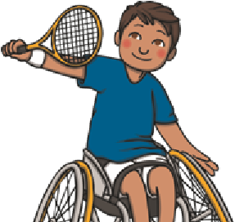 | Year 1 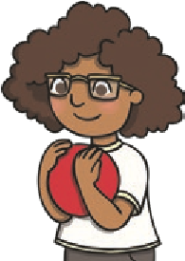 |  |  | Year 2 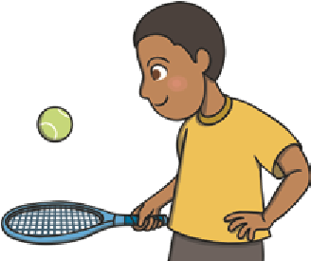 | Year 3 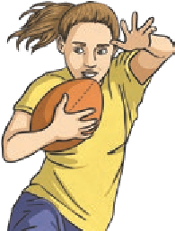 |  |  | Year 4 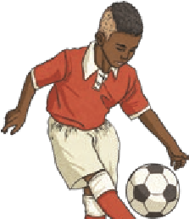 | Year 5 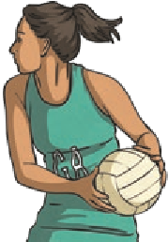 | Year 6 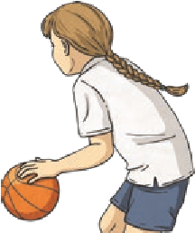
 |  |  |  |  |  |  | Health and Fitness
 |  | Describe how the body feels when still and when exercising. | Describe how the body feels before, during and after exercise.  Carry and place equipment safely. |  |  | Recognise and describe how the body feels during and after different physical activities.  Explain what they need to stay healthy. | Recognise and describe the effects of exercise on the body.  Know the importance of strength and flexibility for physical activity.  Explain why it is important to warmup and cool-down. |  |  | Describe how the body reacts at different times and how this affects performance.  Explain why exercise is good for your health.  Know some reasons for warming up and cooling down. | Know and understand the reasons for warming up and cooling down.  Explain some safety principles when preparing for and during exercise. | Understand the importance of warming up and cooling down.  Carry out warm-ups and cool-downs safely and effectively.  Understand why exercise is good for health, fitness and wellbeing.  Know ways they can become healthier.
 |  |  |  |  |  |  | Striking and Hitting a Ball
 |  | Hit a ball with a bat or racquet. | Use hitting skills in a game.  Practise basic striking, sending and receiving. |  |  | Strike or hit a ball with increasing control.  Learn skills for playing striking and fielding games.  Position the body to strike a ball. | Demonstrate successful hitting and striking skills.  Develop a range of skills in striking (and fielding where appropriate).  Practise the correct batting technique and use it in a game.  Strike the ball for distance. |  |  | Use a bat, racquet or stick (hockey) to hit a ball or shuttlecock with accuracy and control.  Accurately serve underarm.  Build a rally with a partner.  Use at least two different shots in a game situation.  Use hand-eye coordination to strike a moving and a stationary ball. | Use different techniques to hit a ball.  Identify and apply techniques for hitting a tennis ball.  Explore when different shots are best used.  Develop a backhand technique and use it in a game.  Practise techniques for all strokes.  Play a tennis game using an overhead serve. | Hit a bowled ball over longer distances.  Use good hand-eye coordination to be able to direct a ball when striking or hitting.  Understand how to serve in order to start a game.

 | Reception | Year 1 | Year 2 | Year 3 | Year 4 | Year 5 | Year 6
 |  |  |  | Throwing and Catching a Ball
 | Roll equipment in different ways.  Throw underarm.  Throw an object at a target.  Catch equipment using two hands. | Throw underarm and overarm.  Catch and bounce a ball.  Use rolling skills in a game.  Practise accurate throwing and consistent catching. | Throw different types of equipment in different ways, for accuracy and distance.  Throw, catch and bounce a ball with a partner.  Use throwing and catching skills in a game.  Throw a ball for distance.  Use hand-eye coordination to control a ball.  Vary types of throw used. | Throw and catch with greater control and accuracy.  Practise the correct technique for catching a ball and use it in a game.  Perform a range of catching and gathering skills with control.  Catch with increasing control and accuracy.  Throw a ball in different ways (e.g. high, low, fast or slow).  Develop a safe and effective overarm bowl. | Develop different ways of throwing and catching. | Consolidate different ways of throwing and catching, and know when each is appropriate in a game. | Throw and catch accurately and successfully under pressure in a game.
 |  |  |  | Travelling with a Ball
 | Move a ball in different ways, including bouncing and kicking.  Use equipment to control a ball. | Travel with a ball in different ways. Travel with a ball in different directions (side to side, forwards and backwards) with control and fluency. | Bounce and kick a ball whilst moving.  Use kicking skills in a game.  Use dribbling skills in a game. | Move with the ball in a variety of ways with some control.  Use two different ways of moving with a ball in a game. | Move with the ball using a range of techniques showing control and fluency. | Use a variety of ways to dribble in a game with success.  Use ball skills in various ways, and begin to link together. | Show confidence in using ball skills in various ways in a game situation, and link these together effectively.
 |  |  |  | Passing a Ball
 | Kick an object at a target. | Pass the ball to another player in a game.  Use kicking skills in a game. | Know how to pass the ball in different ways. | Pass the ball in two different ways in a game situation with some success. | Pass the ball with increasing speed, accuracy and success in a game situation. | Pass a ball with speed and accuracy using appropriate techniques in a game situation. | Choose and make the best pass in a game situation and link a range of skills together with fluency, e.g. passing and receiving the ball on the move.
 |  |  |  | Possession
 |  |  |  | Know how to keep and win back possession of the ball in a team game. | Occasionally contribute towards  helping their team to keep and win  back possession of the ball in a team game. | Keep and win back possession of the ball effectively in a team game. | Keep and win back possession of the ball effectively and in a variety of ways in a team game.
 |  |  |  | Using Space
 | Move safely around the space and equipment.  Travel in different ways, including sideways and backwards. | Use different ways of travelling in  different directions or pathways.  Run at different speeds.  Begin to use space in a game. | Use different ways of travelling  at different speeds and following  different pathways, directions or courses.  Change speed and direction whilst running.  Begin to choose and use the best space in a game. | Find a useful space and get into it to support teammates. | Make the best use of space to pass and receive the ball. | Demonstrate an increasing awareness of space. | Demonstrate a good awareness of space.

 | Reception | Year 1 | Year 2 | Year 3 | Year 4 | Year 5 | Year 6
 |  |  |  | Attacking and Defending
 | Play a range of chasing games. | Begin to use the terms attacking and defending.  Use simple defensive skills such as marking a player or defending a space.  Use simple attacking skills such as dodging to get past a defender. | Begin to use and understand the terms attacking and defending.  Use at least one technique to attack or defend to play a game successfully. | Use simple attacking and defending skills in a game.  Use fielding skills to stop a ball from travelling past them. | Use a range of attacking and defending skills and techniques in a game.  Use fielding skills as an individual to prevent a player from scoring. | Choose the best tactics for attacking and defending. Shoot in a game.  Use fielding skills as a team to prevent the opposition from scoring. | Think ahead and create a plan of attack or defence.  Apply knowledge of skills for attacking and defending.  Work as a team to develop fielding strategies to prevent the opposition from scoring.
 |  |  |  | Tactics and Rules
 | Follow simple rules. | Follow simple rules to play games, including team games.  Use simple attacking skills such as dodging to get past a defender.  Use simple defensive skills such as marking a player or defending a space. | Understand the importance of rules in games.  Use at least one technique to attack or defend to play a game successfully. | Apply and follow rules fairly.  Understand and begin to apply the basic principles of invasion games.  Know how to play a striking and fielding game fairly. | Vary the tactics they use in a game.  Adapt rules to alter games. | Know when to pass and when to dribble in a game.  Devise and adapt rules to create their own game. | Follow and create complicated rules to play a game successfully.  Communicate plans to others during a game.  Lead others during a game.
 |  |  |  | Compete/Perform
 | Control my body when performing a sequence of movements.  Participate in simple games. | Perform using a range of actions and body parts with some coordination.  Begin to perform learnt skills with some control.  Engage in competitive activities and team games. | Perform sequences of their own composition with coordination.  Perform learnt skills with increasing control.  Compete against self and others. | Develop the quality of the actions in their performances.  Perform learnt skills and techniques with control and confidence.  Compete against self and others in a controlled manner. | Perform and apply skills and techniques with control and accuracy.  Take part in a range of competitive games and activities. | Consistently perform and apply skills and techniques with accuracy and control.  Take part in competitive games with a strong understanding of tactics and composition. | Perform and apply a variety of skills and techniques confidently, consistently and with precision.  Take part in competitive games with a strong understanding of tactics and composition.
 |  |  |  | Evaluate
 | Talk about what they have done.  Talk about what others have done. | Watch and describe performances.  Begin to say how they could improve. | Watch and describe performances, and use what they see to improve their own performance.  Talk about the differences between their work and that of others. | Watch, describe and evaluate the effectiveness of a performance.  Describe how their performance has improved over time. | Watch, describe and evaluate the effectiveness of performances, giving ideas for improvements.  Modify their use of skills or techniques to achieve a better result. | Choose and use criteria to evaluate own and others’ performance.  Explain why they have used particular skills or techniques, and the effect they have had on their performance. | Thoroughly evaluate their own and others’ work, suggesting thoughtful and appropriate improvements.

