 |  | Early Years Outcomes  The main Early Years Outcomes covered in the Gymnastics units are:  - Initiates new combinations of movement and gesture in order to express and respond to feelings, ideas and experiences.  - Experiments with different ways of moving.  - Jumps off an object and lands appropriately.  - Travels with confidence and skill around, under, over and through balancing and climbing equipment. |  |  |  |  | KS1 National Curriculum Aims  The main KS1 national curriculum aims covered in the Gymnastics units are:  • Master basic movements including running, jumping, throwing and catching, as well as developing balance, agility and coordination, and begin to apply these in a range of activities. |  |  |  | KS2 National Curriculum Aims  The main KS2 national curriculum aims covered in the Gymnastics units are:  - Develop flexibility, strength, technique, control and balance [for example, through athletics and gymnastics].  - Compare their performances with previous ones and demonstrate improvement to achieve their personal best.
 | Reception 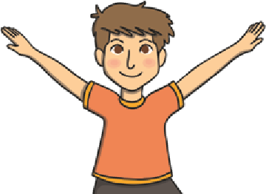 |  | Year 1 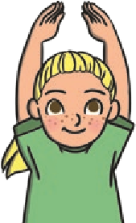 | Year 2 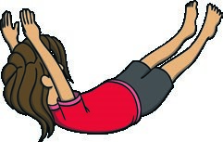 | Year 3 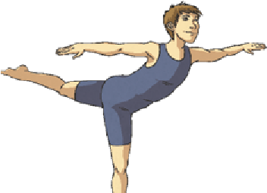 |  |  | Year 4 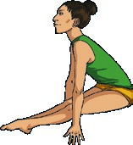 | Year 5 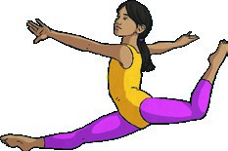 |  |  | Year 6 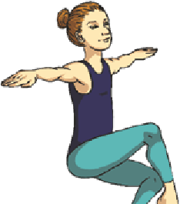
 |  |  |  |  | Health and Fitness
 | Describe how the body feels when still and when exercising. |  | Describe how the body feels before, during and after exercise.  Carry and place equipment safely. | Recognise and describe how the body feels during and after different physical activities.  Explain what they need to stay healthy. | Recognise and describe the effects of exercise on the body.  Know the importance of strength and flexibility for physical activity.  Explain why it is important to warm up and cool down. |  |  | Describe how the body reacts at different times and how this affects performance.  Explain why exercise is good for your health.  Know some reasons for warming up and cooling down. | Know and understand the reasons for warming up and cooling down.  Explain some safety principles when preparing for and during exercise. |  |  | Understand the importance of warming up and cooling down.  Carry out warm-ups and cool-downs safely and effectively.  Understand why exercise is good for health, fitness and wellbeing.  Know ways they can become healthier.
 |  |  |  | Acquiring | and Developing Skills in Gymnastic |  |  | s (General)
 | Create a short sequence of movements.  Roll in different ways with control.  Travel in different ways.  Stretch in different ways.  Jump in a range of ways from one space to another with control. Begin to balance with control.  Move around, under, over, and through different objects and equipment. |  | Create and perform a movement sequence.  Copy actions and movement sequences with a beginning, middle and end. Link two actions to make a sequence.  Recognise and copy contrasting actions (small/tall, narrow/wide).  Travel in different ways, changing direction and speed.  Hold still shapes and simple balances.  Carry out simple stretches.  Carry out a range of simple jumps, landing safely.  Move around, under, over, and through different objects and equipment.  Begin to move with control and care. | Copy, explore and remember actions and movements to create their own sequence.  Link actions to make a sequence.  Travel in a variety of ways, including rolling.  Hold a still shape whilst balancing on different points of the body.  Jump in a variety of ways and land with increasing control and balance.  Climb onto and jump off the equipment safely.  Move with increasing control and care. | Choose ideas to compose a movement sequence independently and with others.  Link combinations of actions with increasing confidence, including changes of direction, speed or level.  Develop the quality of their actions, shapes and balances.  Move with coordination, control and care.  Use turns whilst travelling in a variety of ways.  Use a range of jumps in their sequences.  Begin to use equipment to vault.  Create interesting body shapes while holding balances with control and confidence.  Begin to show flexibility in movements |  |  | Create a sequence of actions that fit a theme.  Use an increasing range of actions, directions and levels in their sequences.  Move with clarity, fluency and expression.  Show changes of direction, speed and level during a performance.  Travel in different ways, including using flight.  Improve the placement and alignment of body parts in balances.  Use equipment to vault in a variety of ways.  Carry out balances, recognising the position of their centre of gravity and how this affects the balance.  Begin to develop good technique when travelling, balancing and using equipment.  Develop strength, technique and flexibility throughout performances. | Select ideas to compose specific sequences of movements, shapes and balances.  Adapt their sequences to fit new criteria or suggestions.  Perform jumps, shapes and balances fluently and with control.  Confidently develop the placement of their body parts in balances, recognising the position of their centre of gravity and where it should be in relation to the base of the balance.  Confidently use equipment to vault in a variety of ways.  Apply skills and techniques consistently.  Develop strength, technique and flexibility throughout performances.  Combine equipment with movement to create sequences. |  |  | Create their own complex sequences involving the full range of actions and movements: travelling, balancing, holding shapes, jumping, leaping, swinging, vaulting and stretching.  Demonstrate precise and controlled placement of body parts in their actions, shapes and balances.  Confidently use equipment to vault and incorporate this into sequences.  Apply skills and techniques consistently, showing precision and control.  Develop strength, technique and flexibility throughout performances.
Whole School Skills Progression Map – Gymnastics

The Gymnastic skills taught throughout the units can be broken down into these specific areas; rolls, jumps, vault work, handstands, cartwheels and round-offs, travelling and shapes and balances.
This table maps out the progression of skills in each area to be taught in each year group. Please note – the age range is only a guide. All skills should be taught depending on the gymnastic ability of the children. Many of the skills are repeated across year groups to allow for children to progress at their own pace. For example, if a child has not mastered a forward roll from standing in year 3, the skill can be revisited in year 4, 5 and 6 if necessary.
 | Reception | Year 1 | Year 2 | Year 3 | Year 4 | Year 5 | Year 6
 |  |  | Rolls
 | Curled side roll (egg roll)  Log roll (pencil roll)  Teddy bear roll | Log roll (controlled)  Curled side roll (egg roll) (controlled)  Teddy bear roll (controlled) | Log roll (controlled)  Curled side roll (egg roll) (controlled)  Teddy bear roll (controlled)  Rocking for forward roll  Crouched forward roll | Crouched forward roll  Forward roll from standing  Tucked backward roll | Forward roll from standing  Straddle forward roll  Tucked backward roll  Backward roll to straddle | Forward roll from standing  Straddle forward roll  Pike forward roll  Tucked backward roll  Backward roll to straddle | Forward roll from standing  Straddle forward roll  Pike forward roll  Dive forward roll  Tucked backward roll  Backward roll to straddle  Backward roll to standing pike  Pike backward roll
 |  |  | Jumps
 | Straight jump  Tuck jump  Jumping Jack  Half turn jump | Straight jump  Tuck jump  Jumping jack  Half turn jump  Cat spring | Straight jump  Tuck jump  Jumping jack  Half turn jump  Cat spring  Cat spring to straddle | Straight jump  Tuck jump  Jumping jack  Star jump  Straddle jump  Pike jump  Straight jump half-turn  Cat leap | Straight jump  Tuck jump  Jumping jack  Star jump  Straddle jump  Pike jump  Straight jump half-turn  Straight jump full-turn  Cat leap  Cat leap half-turn | Straight jump  Tuck jump  Jumping jack  Star jump  Straddle jump  Pike jump  Stag jump  Straight jump half-turn  Straight jump full-turn  Cat leap  Cat leap half-turn  Split leap | Straight jump  Tuck jump  Jumping jack  Star jump  Straddle jump  Pike jump  Stag jump  Straight jump half-turn  Straight jump full-turn  Cat leap  Cat leap half-turn  Cat leap full-turn  Split leap Stag leap
 |  |  | Vault – with springboard and vault or other suitable raised platform, e.g. gymnastics table
 |  | Straight jump off springboard | Hurdle step onto springboard  Straight jump off springboard  Tuck jump off springboard | Hurdle step onto springboard  Squat on vault  Star jump off  Tuck jump off  Straddle jump off  Pike jump off | Hurdle step onto springboard  Squat on vault  Straddle on vault  Star jump off  Tuck jump off  Straddle jump off  Pike jump off | Hurdle step onto springboard  Squat on vault  Straddle on vault  Star jump off  Tuck jump off  Straddle jump off  Pike jump off  Squat through vault | Hurdle step onto springboard  Squat on vault  Straddle on vault  Star jump off  Tuck jump off  Straddle jump off  Pike jump off  Squat through vault  Straddle over vault

 | Reception | Year 1 | Year 2 | Year 3 | Year 4 | Year 5 | Year 6
 |  |  | Handstands, Cartwheels and Round-offs
 | Bunny hop | Bunny hop  Front support wheelbarrow with partner | Bunny hop  Front support wheelbarrow with partner  T-lever  Scissor kick | Handstand  Lunge into handstand  Cartwheel | Lunge into handstand  Lunge into cartwheel | Lunge into handstand  Lunge into cartwheel  Lunge into round-off | Lunge into cartwheel  Lunge into round-off  Hurdle step  Hurdle step into cartwheel  Hurdle step into round-off
 |  |  | Travelling & Linking Actions
 | Tiptoe, step, jump and hop | Tiptoe, step, jump and hop  Hopscotch  Skipping  Galloping | Tiptoe, step, jump and hop  Hopscotch  Skipping  Galloping  Straight jump half-turn | Tiptoe, step, jump and hop  Hopscotch  Skipping  Chassis steps  Straight jump half turn  Cat leap | Tiptoe, step, jump and hop  Hopscotch  Skipping  Chassis steps  Straight jump half turn  Straight jump full turn  Cat leap  Cat leap half turn  Pivot | Tiptoe, step, jump and hop  Hopscotch  Skipping  Chassis steps  Straight jump half turn  Straight jump full turn  Cat leap  Cat leap half turn  Pivot | Tiptoe, step, jump and hop  Hopscotch  Skipping  Chassis steps  Straight jump half turn  Straight jump full turn  Cat leap  Cat leap half turn  Cat leap full turn  Pivot
 |  |  | Shapes and Balances
 | Standing balances | Standing balances  Kneeling balances  Pike, tuck, star, straight, straddle shapes | Standing balances  Kneeling balances  Large body part balances  Balances on apparatus  Balances with a partner  Pike, tuck, star, straight, straddle shapes  Front and back support | Large and small body part balances, including standing and kneeling balances  Balances on apparatus  Matching and contrasting partner balances  Pike, tuck, star, straight, straddle shapes  Front and back support | 1, 2, 3 and 4- point balances  Balances on apparatus  Balances with and against a partner Pike, tuck, star, straight, straddle shapes  Front and back support | 1, 2, 3 and 4- point balances  Balances on apparatus  Part body weight partner balances Pike, tuck, star, straight, straddle shapes  Front and back support | 1, 2, 3 and 4- point balances  Balances on apparatus  Develop technique, control and complexity of part-weight partner balances  Group formations  Pike, tuck, star, straight, straddle shapes  Front and back support
 |  |  | Compete/Perform
 | Control my body when performing a sequence of movements.  Participate in simple games. | Perform using a range of actions and body parts with some coordination.  Begin to perform learnt skills with some control. | Perform sequences of their own composition with coordination.  Perform learnt skills with increasing control. | Develop the quality of the actions in their performances.  Perform learnt skills and techniques with control and confidence.  Compete against self and others in a controlled manner. | Perform and create sequences with fluency and expression.  Perform and apply skills and techniques with control and accuracy. | Perform own longer, more complex sequences in time to music.  Consistently perform and apply skills and techniques with accuracy and control. | Link actions to create a complex sequence using a full range of movement that showcases different agilities, performed in time to music.  Perform and apply a variety of skills and techniques confidently, consistently and with precision.  Begin to record their peers’ performances, and evaluate these.

