Whole School Skills Progression Map – OUTDOOR ADVENTUROUS ACTIVITY
KS2 National Curriculum Aims
Pupils should continue to apply and develop a broader range of skills, learning how to use them in different ways and to link them to make actions and sequences of movement. They should enjoy communicating, collaborating and competing with each other. They should develop an understanding of how to improve in different physical activities and sports and learn how to evaluate and recognise their own success.
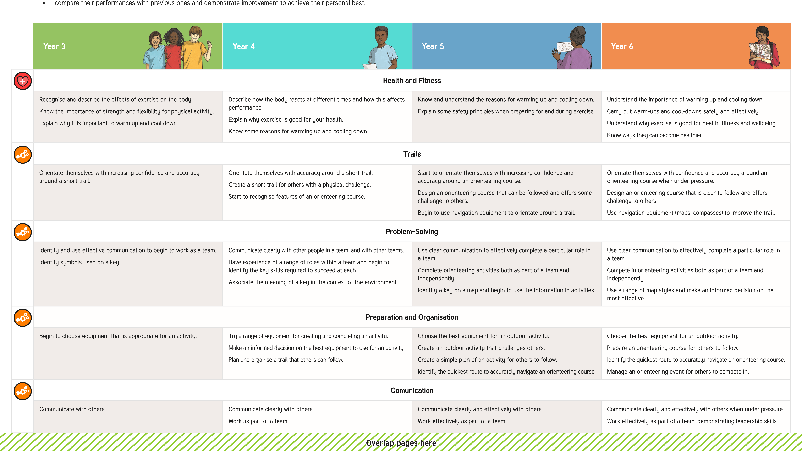
- Pupils should be taught to: - take part in outdoor and adventurous activity challenges both individually and within a team- Compare their performances with previous ones and demonstrate improvement to achieve their personal best.

 |  | Begin to use a map to complete an orienteering course. | Successfully use a map to complete an orienteering course.  Begin to use a compass for navigation. | when necessary.  Successfully use a map to complete an orienteering course.  Use a compass for navigation.  Organise an event for others.
 |  | Compete and Perform
 | Begin to complete activities in a set period of time.  Begin to offer an evaluation of personal performances and activities. | Complete an orienteering course more than once and begin to identify ways of improving completion time.  Offer an evaluation of both personal performances and activities.  Start to improve trails to increase the challenge of the course. | Complete an orienteering course on multiple occasions, in a quicker time due to improved technique.  Offer a detailed and effective evaluation of both personal performances and activities.  Improve a trail to increase the challenge of the course. | Complete an orienteering course on multiple occasions, in a quicker time due to improved technique.  Offer a detailed and effective evaluation of both personal performances and activities with an aim of increasing challenge and improving performance.  Listen to feedback and improve an orienteering course from it.
 |  | Evaluate
 | Watch, describe and evaluate the effectiveness of a performance.  Describe how their performance has improved over time. | Watch, describe and evaluate the effectiveness of performances, giving ideas for improvements.  Modify their use of skills or techniques to achieve a better result. | Choose and use criteria to evaluate own and others’ performances.  Explain why they have used particular skills or techniques, and the effect they have had on their performance. | Thoroughly evaluate their own and others’ work, suggesting thoughtful and appropriate improvements.

