Year 3 Challenge - Week Commencing 11th May, 2020
World War Two Rationing
In Year 3 this term, we would have been studying ‘World War Two’ and with the celebration of the 75th anniversary of VE Day just last Friday, we thought it would be a lovely idea to set you all a wartime challenge this week.
World War Two had a big impact on the food eaten by British people. Before the war, Britain had relied on food imported from all over the world, but with enemy attacks on British ships, food shortages began. To make sure food was shared fairly, the government introduced rationing. People were also encouraged to grow their own food in gardens, parks and allotments.
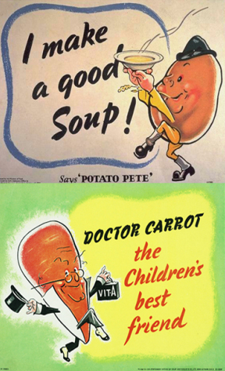
Posters were put up encouraging children to eat their fruit and vegetables and characters such as ‘Potato Pete’ and ‘Dr Carrot’ helped to spread the word and appeal to children.
This week, we would like you to find a wartime recipe that you like the look of and have a go at making it at home with your family.
Perhaps you might choose Carrot Cookies or Leek and Potato soup? Maybe it will be Bread Pudding or Rock Buns? Or maybe something totally different?
We would love you to write out the recipe for us to see so we can maybe have a go at making it ourselves and if you could also include some photographs of you in the process of making it, then that would be even better!
Let us know if you and your family liked the taste, was it something you’d have all enjoyed eating during World War Two or was it quite different to some of the tastes you’re used to? Did you make any changes to the original recipe or did you stick to it exactly?
We hope you will have lots of fun rising to this challenge and look forward to hearing from you later in the week!

