Year 3 Challenge - Week Commencing 18th May, 2020
World War Two Air Raid Shelters
For this week’s challenge, we thought we would continue with the World War Two theme but turn your attention to air raid shelters.

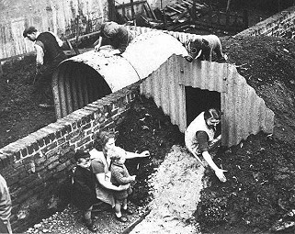
During the war, Germany attacked the major cities of Great Britain from the air by dropping bombs during evening air raids. The people of Britain needed to protect themselves so they built air raid shelters in their gardens. The government gave out Anderson Shelters free to people and by the start of the war in September 1939, one and a half million Anderson shelters had been constructed in gardens.

Anderson shelters were half buried in the ground with earth heaped on top to protect them from bomb blasts. They were made from corrugated iron sheets bolted together at the top and steel plates at either end. The entrance was protected by a steel shield.
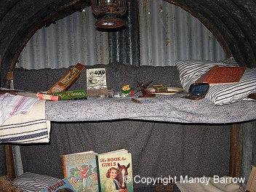
Inside they were dark and damp and people did not enjoy using them at night. In some areas, the shelters would often flood and it was difficult to sleep due to the noise of bombs dropping and exploding.

This week, we would like you to have a go at making your own Anderson shelter and you can you ANY material of your choice.
You might wish to make one out of lego, clay, recycling materials such as plastic or cardboard, boxes or packaging, you could use papier mache or even just build your own den in the style of an Anderson Shelter! The choice is yours!
We would love to see some photographs of you with your shelters and most importantly, we hope you have lots of fun making them!

