Year 5 Weekly Challenge 1
What can you make from an empty toilet or kitchen roll?
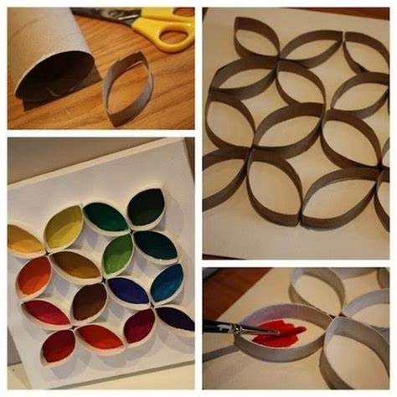
Here are some ideas…
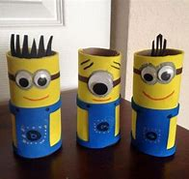
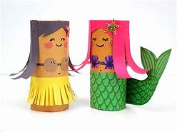

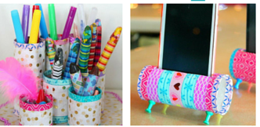
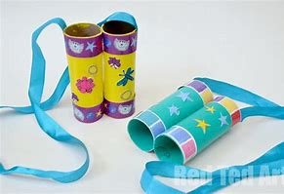

We cannot wait to see what you come up with!

Please send in your photos to either:
Frome@nauntonpark.gloucs.sch.uk
Severn@nauntonpark.gloucs.sch.uk

Mrs Walls & Mrs Morrish.

