Year 5 Weekly Challenge 2
Get out into your garden, street or local park and be a tree detective… Design your own tree chart, see below; take a photograph of your work; and send it to us. We have also included a leaf identification sheet to help you.
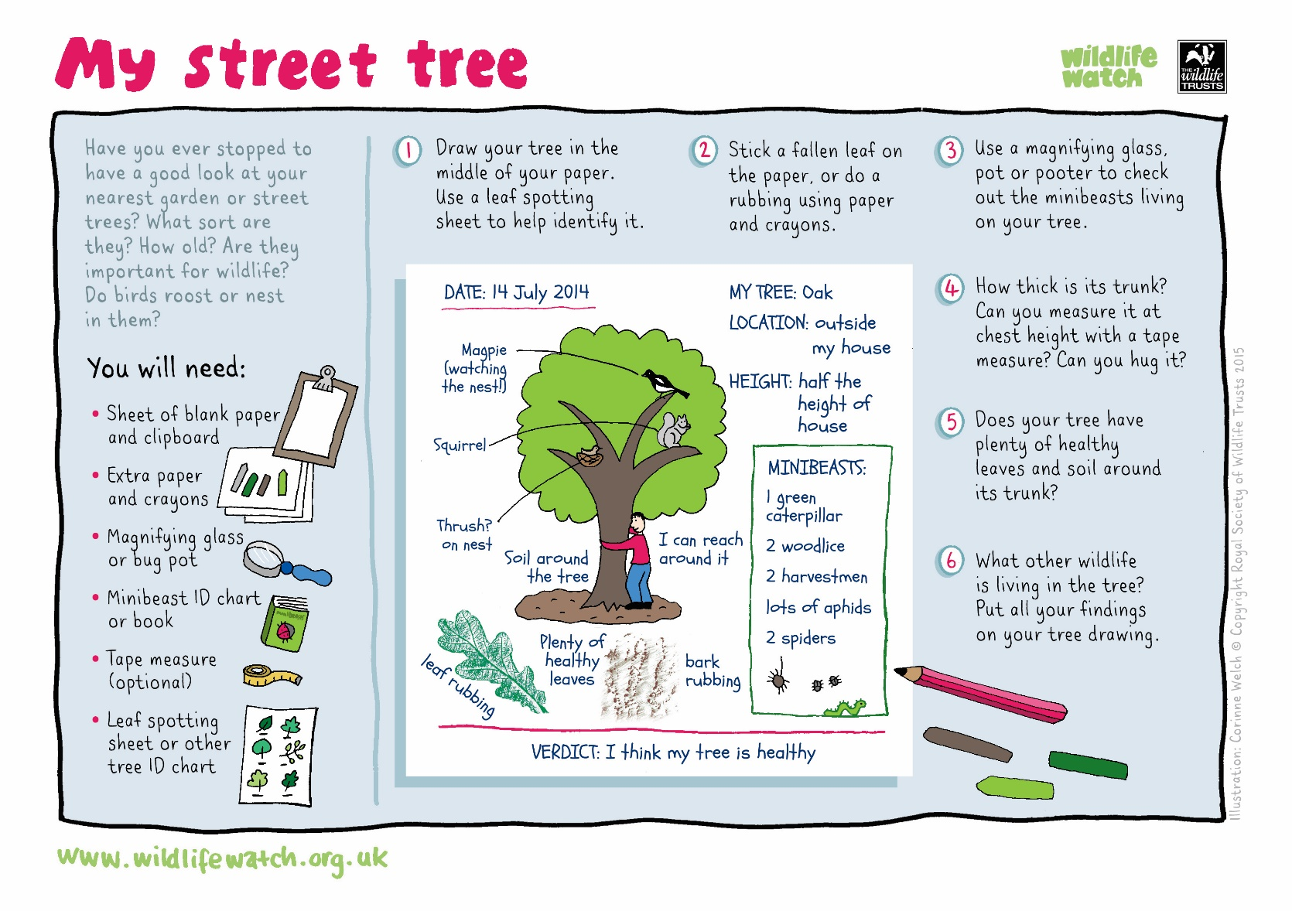
We can’t wait to see the variety of trees you find.
Please send in your photos to either:
Frome@nauntonpark.gloucs.sch.uk
Severn@nauntonpark.gloucs.sch.uk

Mrs Walls & Mrs Morrish

